CGT270 Midterm Part II

Data Visualization Challenge

Student:

Kailan Barnes

Professor

Dr. Vetria Byrd

TA

Subia Ansari

Course:

CGT 27000 Data Visualization

Term:

Fall 2021

Contents

Halloween Visualization 3

Data Description 3

Location of home 4

Example 4

The Assignment 5

Data Visualization Process 6

Acquire 6

The Data 6

Parse & Mine 7

Represent 8

Filter 11

Critique 12

Refine 13

What’s the story? 16

# Halloween Visualization

This in-class assignment is to create data visualizations using data collected about trick-or-treaters in Cincinnati, OH. **You should create two (2) visualizations**, this can be a collection of charts or a dashboard, whatever is necessary to the story or analysis that is shown in your visualizations. Make sure you **READ and FOLLOW ALL Instructions**. The goal is to demonstrate your understanding of the data visualization process.

# Data Description

|  |  |  |
| --- | --- | --- |
| The data is available in two formats   * Halloween data for Excel 2020 is a crosstab table which is ideal for creating visualizations in Excel. Numbers in the data file for Excel are **cumulative**. * Halloween data for Tableau 2020” is unpivoted which is ideal for creating visualizations in Tableau. Numbers in the data file for Tableau are **not cumulative**. * The data has been collected since 2008. * The numbers in the table are cumulative totals of the number of trick-or-treaters who visited one house each year. * The numbers are measured at 30-minute intervals, except for the last 15-minute interval. |  | * The trick-or-treat count was recorded in 30-minute intervals except for the last 15-minute interval. * The night of trick-or-treating has always been on October 31st each year (some neighborhoods change the night of trick-or-treating). * Official tick or treat hours are from 6 PM to 8 PM, but there are often “stragglers” past 8 PM that are not turned away. These stragglers are counted in the 8PM – 8:15 PM time slot. There has never been a trick-or-treater past 8:15 PM. * The type of candy did not vary year-by-year. It is always a general mix of candy purchased in bulk variety bags. |

## Location of home

Neighborhood: East Walnut Hills/Evanston

City, State: Cincinnati, Ohio

Zip code: 45207

Being a corner house on the neighborhood border likely increases the number of trick-or-treaters.

## Example

Here’ an example of how previous Halloween data have been visualized. Be creative!

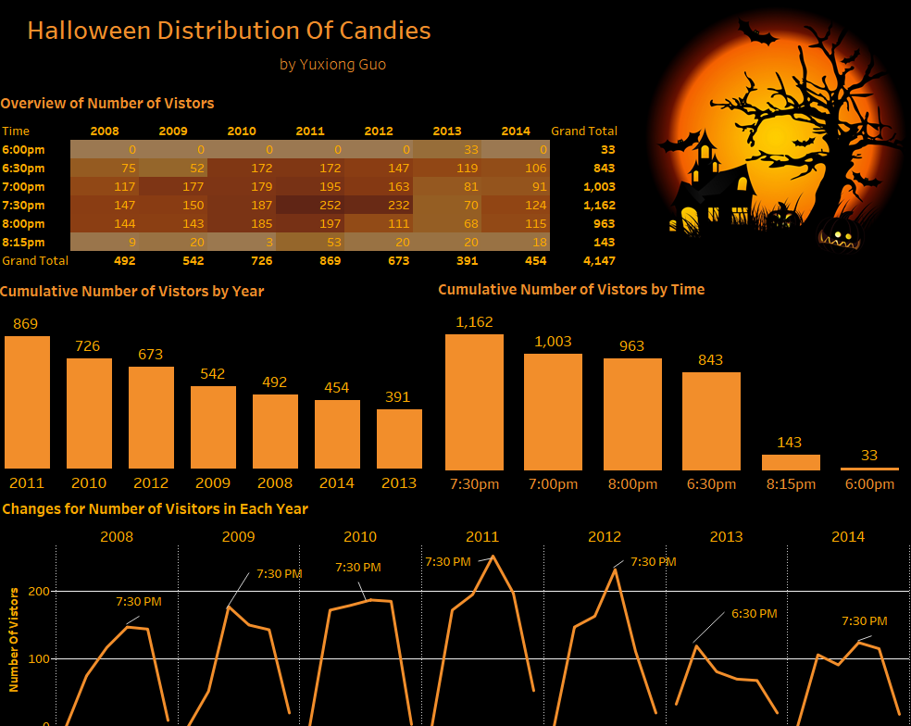

# The Assignment

There are multiple parts to this assignment. Make sure you read the entire assignment before starting.

Determine a story or goal to support the two (2) visualizations you will create using the Halloween data provided. Your two visualization MUST be different chart types. **This means DO NOT create two bar charts or two-line charts or two of the same chart types!** Challenge yourself. This is your time to show what you know.

Examples (these are examples):

* Homeowner dashboard summarizing Halloween
* Forecast future trick-or-treaters or estimate future candy needed
* Explore variation of the number of trick-or-treaters year by year
* **Be creative and think of other things you could do**

# Data Visualization Process

Show your understanding of the data visualization process.

# Acquire

## The Data

|  |  |  |  |  |  |  |
| --- | --- | --- | --- | --- | --- | --- |
| **Year** | **6pm** | **6:30pm** | **7pm** | **7:30pm** | **8pm** | **Total (8:15pm)** |
| 2020 | 11 | 55 | 107 | 155 | 211 | 219 |
| 2019 | 0 | 117 | 262 | 406 | 483 | 523 |
| 2018 | 18 | 191 | 342 | 497 | 589 | 600 |
| 2017 | 41 | 190 | 357 | 549 | 710 | 776 |
| 2016 | 22 | 160 | 386 | 612 | 759 | 822 |
| 2015 | 13 | 148 | 336 | 523 | 667 | 747 |
| 2014 | 0 | 106 | 197 | 321 | 436 | 454 |
| 2013 | 33 | 152 | 233 | 303 | 371 | 391 |
| 2012 | 0 | 147 | 310 | 542 | 653 | 673 |
| 2011 | 0 | 172 | 367 | 619 | 816 | 869 |
| 2010 | 0 | 172 | 351 | 538 | 723 | 726 |
| 2009 | 0 | 52 | 229 | 379 | 522 | 542 |
| 2008 | 0 | 75 | 192 | 339 | 483 | 492 |

Excel and Tableau versions of the data are provided in Brightspace. **Choose one (1) to work with**.

* HalloweenExcel
* HalloweenTableau

# Parse & Mine

Use this page to provide a parsing of the data. For quantitative fields list some basic statistical procedures that can be performed in the space below. To be clear, you are to list the procedure (you are not required to actually do any calculations here).

Use the Tab key to add more rows to the table below.

|  |  |  |
| --- | --- | --- |
| **Variable** | **Data type** | **Statistical Method**  **(where applicable)** |
| Year | Integer | Range |
| Time | Integer | Range |
| Number of trick or treaters | Integer | Maximum, Minimum, Average, Mean |

# Represent

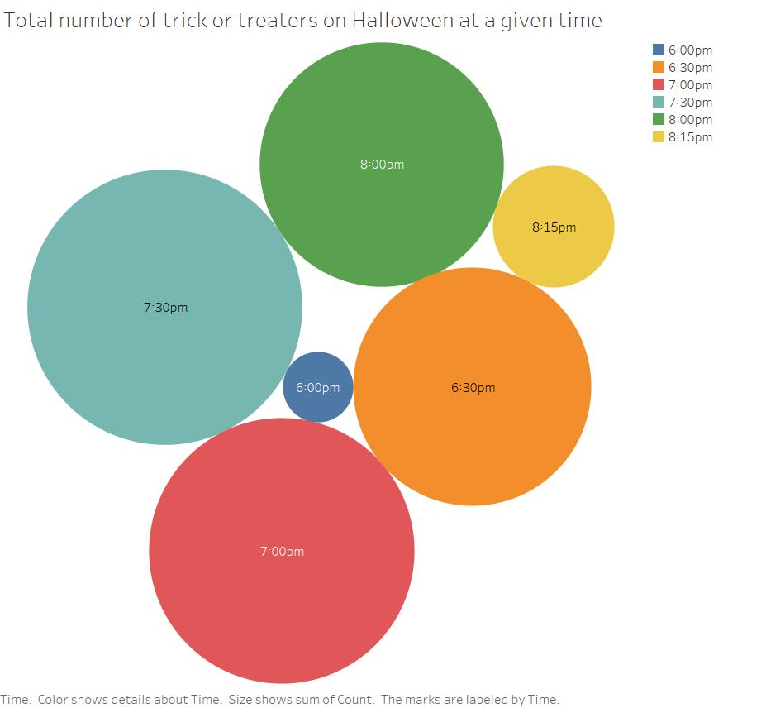 Figure 1: The total number of trick or treaters at a given time on Halloween. The values were totaled from Halloween 2008 to Halloween 2020 in East Walnut Hills/Evanston, Cincinnati, Ohio.

**Helpful Tip: Utilize the space that you have. Do NOT create a tiny visualization that is unreadable. Remember, the purpose of visualization is insight, but all insight is lost if it cannot be seen.**

`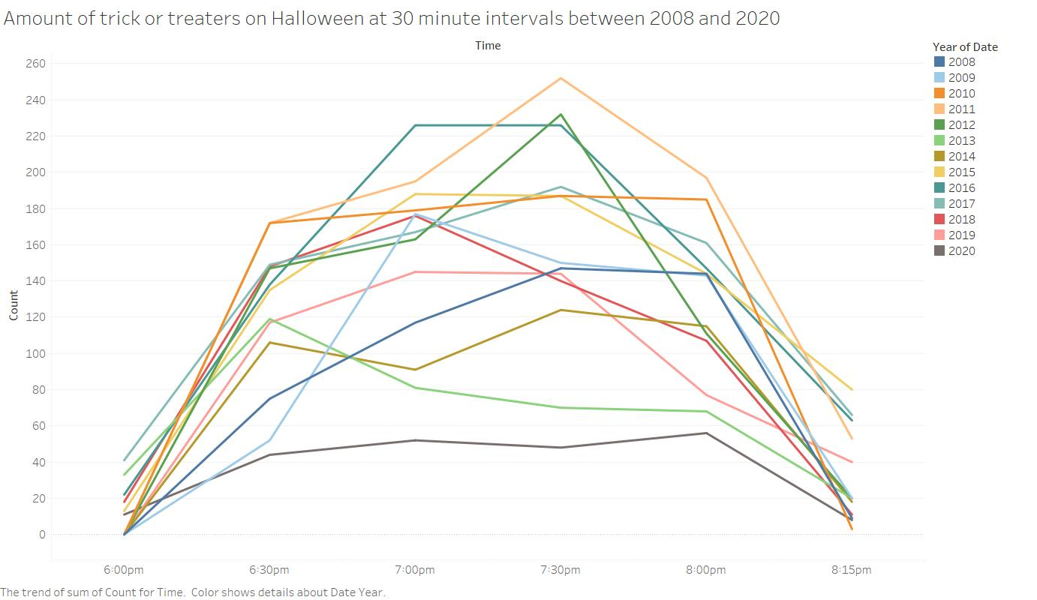

Figure 2: A visualization of the number of trick or treaters at the given time intervals between 2008 and 2020. These values were collected from East Walnut Hills/Evanston, Cincinnati, Ohio.

# Filter

In this page show the data you used to create your visualizations.

**Figure 1**

|  |  |  |  |  |  |  |
| --- | --- | --- | --- | --- | --- | --- |
| Time | 6:00pm | 6:30pm | 7:00pm | 7:30pm | 8:00pm | 8:15pm |
| Total: | 138 | 1574 | 1957 | 2099 | 1655 | 411 |

**Figure 2**

|  |  |  |
| --- | --- | --- |
| Date | Count | Time |
| 10/31/2008 | 0 | 6:00pm |
| 10/31/2009 | 0 | 6:00pm |
| 10/31/2010 | 0 | 6:00pm |
| 10/31/2011 | 0 | 6:00pm |
| 10/31/2012 | 0 | 6:00pm |
| 10/31/2013 | 33 | 6:00pm |
| 10/31/2014 | 0 | 6:00pm |
| 10/31/2015 | 13 | 6:00pm |
| 10/31/2016 | 22 | 6:00pm |
| 10/31/2017 | 41 | 6:00pm |
| 10/31/2018 | 18 | 6:00pm |
| 10/31/2019 | 0 | 6:00pm |
| 10/31/2020 | 11 | 6:00pm |
| 10/31/2008 | 75 | 6:30pm |
| 10/31/2009 | 52 | 6:30pm |
| 10/31/2010 | 172 | 6:30pm |
| 10/31/2011 | 172 | 6:30pm |
| 10/31/2012 | 147 | 6:30pm |
| 10/31/2013 | 119 | 6:30pm |
| 10/31/2014 | 106 | 6:30pm |
| 10/31/2015 | 135 | 6:30pm |
| 10/31/2016 | 138 | 6:30pm |
| 10/31/2017 | 149 | 6:30pm |
| 10/31/2018 | 148 | 6:30pm |
| 10/31/2019 | 117 | 6:30pm |
| 10/31/2020 | 44 | 6:30pm |
| 10/31/2008 | 117 | 7:00pm |
| 10/31/2009 | 177 | 7:00pm |
| 10/31/2010 | 179 | 7:00pm |
| 10/31/2011 | 195 | 7:00pm |
| 10/31/2012 | 163 | 7:00pm |
| 10/31/2013 | 81 | 7:00pm |
| 10/31/2014 | 91 | 7:00pm |
| 10/31/2015 | 188 | 7:00pm |
| 10/31/2016 | 226 | 7:00pm |
| 10/31/2017 | 167 | 7:00pm |
| 10/31/2018 | 176 | 7:00pm |
| 10/31/2019 | 145 | 7:00pm |
| 10/31/2020 | 52 | 7:00pm |
| 10/31/2008 | 147 | 7:30pm |
| 10/31/2009 | 150 | 7:30pm |
| 10/31/2010 | 187 | 7:30pm |
| 10/31/2011 | 252 | 7:30pm |
| 10/31/2012 | 232 | 7:30pm |
| 10/31/2013 | 70 | 7:30pm |
| 10/31/2014 | 124 | 7:30pm |
| 10/31/2015 | 187 | 7:30pm |
| 10/31/2016 | 226 | 7:30pm |
| 10/31/2017 | 192 | 7:30pm |
| 10/31/2018 | 140 | 7:30pm |
| 10/31/2019 | 144 | 7:30pm |
| 10/31/2020 | 48 | 7:30pm |
| 10/31/2008 | 144 | 8:00pm |
| 10/31/2009 | 143 | 8:00pm |
| 10/31/2010 | 185 | 8:00pm |
| 10/31/2011 | 197 | 8:00pm |
| 10/31/2012 | 111 | 8:00pm |
| 10/31/2013 | 68 | 8:00pm |
| 10/31/2014 | 115 | 8:00pm |
| 10/31/2015 | 144 | 8:00pm |
| 10/31/2016 | 147 | 8:00pm |
| 10/31/2017 | 161 | 8:00pm |
| 10/31/2018 | 107 | 8:00pm |
| 10/31/2019 | 77 | 8:00pm |
| 10/31/2020 | 56 | 8:00pm |
| 10/31/2008 | 9 | 8:15pm |
| 10/31/2009 | 20 | 8:15pm |
| 10/31/2010 | 3 | 8:15pm |
| 10/31/2011 | 53 | 8:15pm |
| 10/31/2012 | 20 | 8:15pm |
| 10/31/2013 | 20 | 8:15pm |
| 10/31/2014 | 18 | 8:15pm |
| 10/31/2015 | 80 | 8:15pm |
| 10/31/2016 | 63 | 8:15pm |
| 10/31/2017 | 66 | 8:15pm |
| 10/31/2018 | 11 | 8:15pm |
| 10/31/2019 | 40 | 8:15pm |
| 10/31/2020 | 8 | 8:15pm |

# Critique

Rate your visualizations (Figure 1 and Figure 2) using the link below

<https://stephanieevergreen.com/rate-your-visualization/>

**Figure 1 Rating**

**Figure 2 Rating**

# Refine

In this part of the visualization challenge, you should identify one or more characteristics of the visualizations you created (Figure 1 and Figure 2) and update the figures. Include an updated version of each Figure below. In the figure caption, state what changes were made.

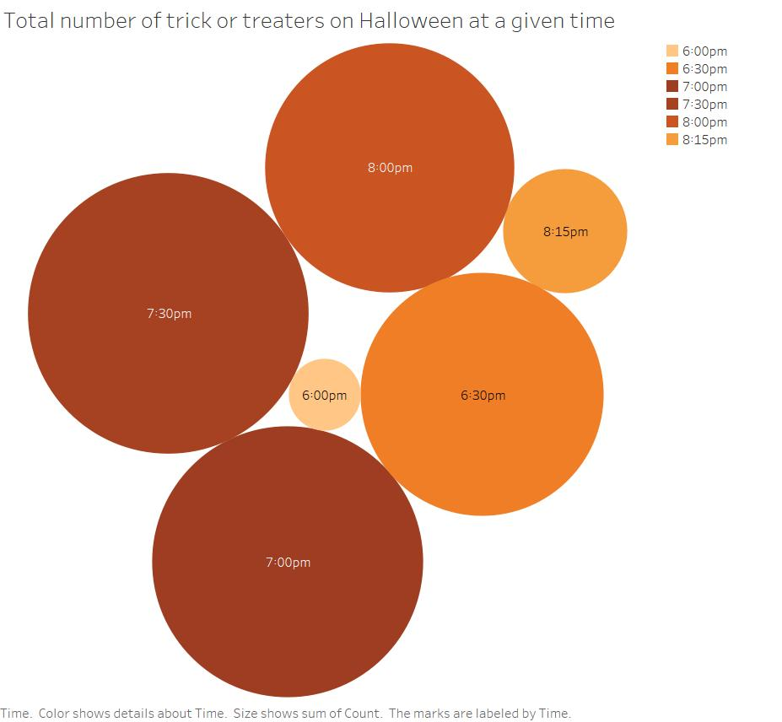

Figure 1 Refined. I changed the colors to better represent the trend I am hoping to show, as well as making the colors associated with Halloween. The lighter colors are associated with less people, while darker colors have more people.

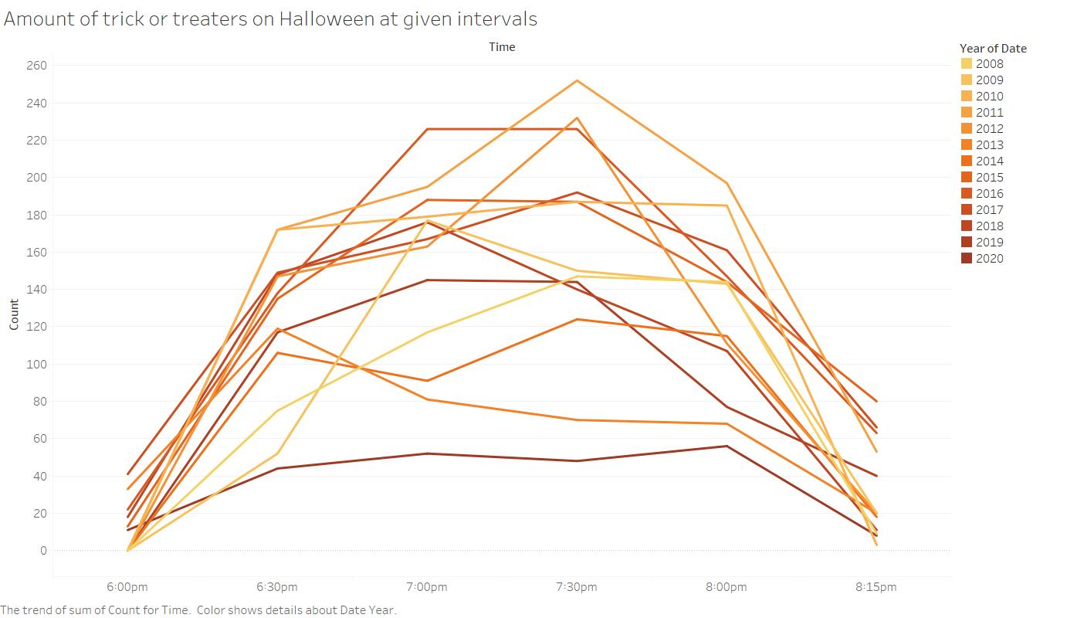

Figure 2 Refined. I shortened the title since I realized it was too long and I could include that information in the caption instead. I also changed the colors to better fit a fall theme, as well as show how there seems to be less trick or treaters as the years go by.

# What’s the story?

Using complete sentences, answer the following questions:

1. During Halloween, kids get to go out and ask for candy from neighboring houses. But as the years go by, it becomes more apparent that there are kids, for various reasons, that are best to go trick or treating when there are less people about. Using Figure 1 Refined, we can see that the times that have the least trick or treaters are 6 pm and 8:15 pm. This fact is also supported by Figure 2 Refined, which shows that the lowest number of trick or treaters each year is either at 6 pm or 8:15 pm. Figure 2 Refined also shows that there is a trend as the years go by that there are less people trick or treating, so they may be comfortable going out at times such as 7 pm or 7:30 pm where there are about 40 trick or treaters out compared to hundreds. So if you wish to trick or treat this year in the East Walnut Hills/Evanston, Cincinnati area, your best time to go 6 pm, when there is likely zero other people trick or treating.
2. The targeted audience is socially anxious children or parents with children with disabilities, such as wheelchair bound or autism that make navigating crowds difficult.
3. List 3 assumptions you made while implementing the data visualization process?
   1. The data was reported by counting trick or treaters and not estimating the numbers at a given time.
   2. The reporting houses were chosen randomly, to give an even distribution of the area and not target for houses who typically had the greatest number of trick or treaters.
   3. The people who view the visualizations seek to find the time when there are the least people around.

Points will be taken off for incomplete sentences.

Bonus points for REALLY GOOD stories!

**Checklist of what to submit:**

* **Save this file as LastnameFirstInitial_CGT270Fall2021_MidtermPartII.pdf**
* **Only submit one (1) file. All of your work should be contained in this file.**
* **Failure to follow these instructions will result in your work NOT being graded.**

**General Deductions (others made accordingly)**

* **No name on the first page of the document: -5 pts**
* **Altered template: -10 pts**
* **No figures included: -15 pts for each missing figure**
* **No figure captions: -10 pts for each missing caption**
* **Zip file submitted: See Checklist of what to submit (-80 pts)**
* **Late submissions: Will NOT be graded (-80 pts)**
* **Provided a link to visualizations instead of providing screenshot of the visualization: this will be treated as no figure, no figure caption (-25 pts)**
* **Failure to follow data visualization best practices (data visualization checklist): deductions made appropriately.**

**Keep in mind: one (1) second after the submission deadline is considered late.**



Byrd Data Visualization Lab